**CHAPTER 7**

**RESULTS**

# Figure 7.1: Welcome page

### 

### Figure 7.2: Login and signup form

### 

### Figure 7.3: Cars details

### 

### Figure 7.4: Booking and Payment pages

### 

### Figure 7.5: Customer report

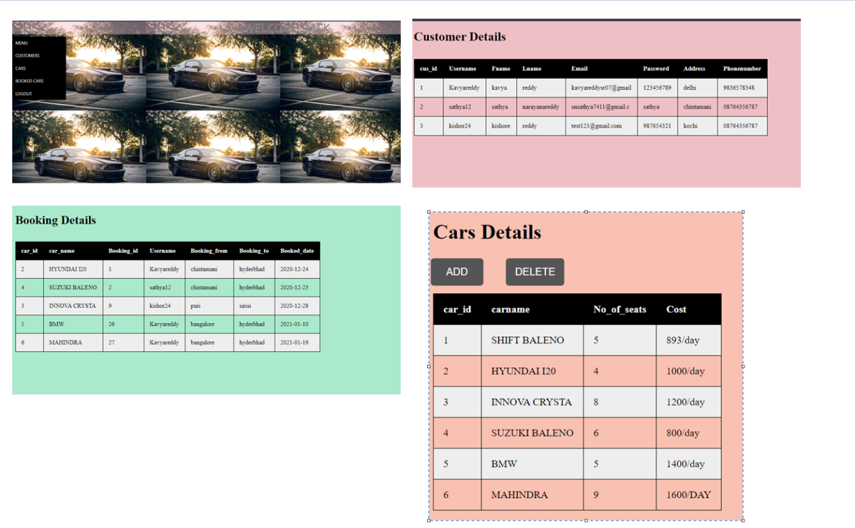

### Figure 7.6: Admin page (Registered customer, Booked cars, Available cars details)